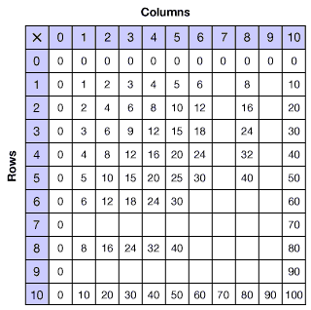

http://www.eduplace.com/math/mw/background/3/06/te_3_06_mult_develop1.html
