Name:______________________________ Date:___________________

Patterns Quiz

- Draw a repeating pattern using shapes where two attributes change. Circle the core of your pattern.

The two attributes that change are ________________ and ________________

- Write the next three numbers in each of the patterns below

3, 6, 9, 12, ____, ____, ____

27, 32, 37, 42, ____, ____, ____

24, 30, 36, 42, ____, ____, _____

32, 28, 24, 20, ____, ____, ____

63, 54, 45 , 36, ____, ____, ____

- Use the following pattern rules to write the first 5 numbers of each pattern

Start at 0. Add 8 each time _____, _____, _____, _____, _____

Start at 40. Subtract 5 each time _____, _____, _____, _____, _____

Start at 28. Add 7 each time _____, _____, _____, _____, _____

Start at 56. Subtract 8 each time _____, _____, _____, _____

- Horatio uses toothpicks to make the pattern below.
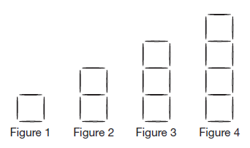

How many toothpicks does he need to make figure 7 and figure 8?

Figure 7 _________ toothpicks Figure 8 ________ toothpicks

