Name: ______________________

Probability: Show What You Know So Far...

- Imagine that a new student is about to join the class. Decide which of these statements is likely, which is certain, which is unlikely, and which is impossible.

Statements | certain | likely | unlikely | impossible
The student is the same age as many other students in the class.
The student is 20 years old.
The student is a boy.
The student has a head.
The student lives in the local area.

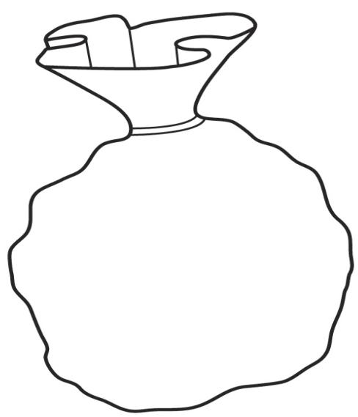
- A marble is picked from this bag.

What is the chance of picking:

- A green marble? ________________
yellow
blue
green
yellow
- A yellow marble? _______________
green
green
- A blue marble? ________________
blue
yellow

green
green
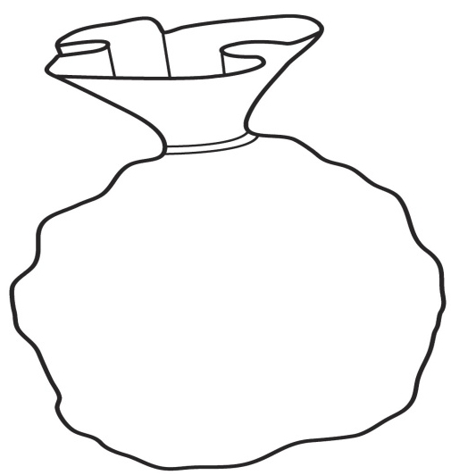

- Describe or draw what 10 colour tiles you would put in
a bag so that the probability of selecting a red one is
high, but not certain.

_____________________________________________________

_____________________________________________________

_____________________________________________________

- For question 3, above, how many red tiles did you put in your bag? Why did you choose that number?

I chose _____ red tiles because _____________________________________________

____________________________________________________________________________

- Could you have chosen a different number of red tiles? Explain your thinking.

____________________________________________________________________________

____________________________________________________________________________

____________________________________________________________________________

- Selver spun one of these spinners 10 times. The results were 4, 4, 3, 1, 4, 2, 4, 3, 1.

Which of these two spinners did she probably use? How do you know?

Spinner A Spinner B

_____________________________________________________________________________

_____________________________________________________________________________

_____________________________________________________________________________

- Use a number cube, a spinner or some cards to create a game that is fair.

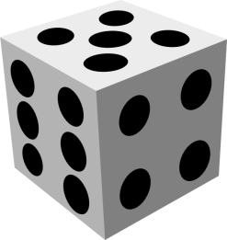

Explain how the game works:

_____________________________________________________________________________

_____________________________________________________________________________

_____________________________________________________________________________

_____________________________________________________________________________

_____________________________________________________________________________

_____________________________________________________________________________

How do you know it is a fair game?

_____________________________________________________________________________

_____________________________________________________________________________

_____________________________________________________________________________

